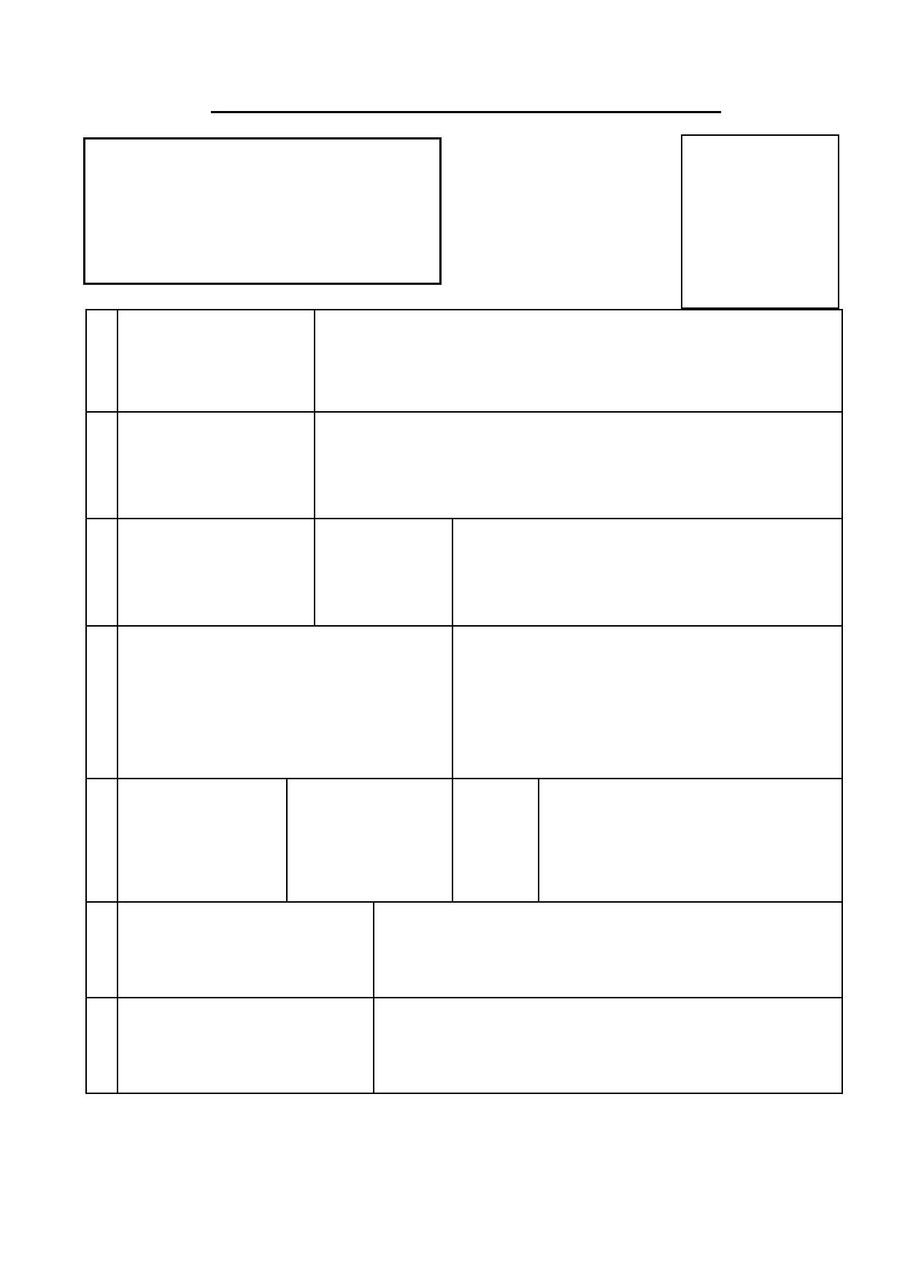

To be returned:

To
FORM OF APPLICATION FOR THE POST OF

Photograph

(The PI)

1. Name in full (in capital
letters) (Underline Surname)

2. Father's / Husband's Name

3. a. Marital Status b. Male / Female :

4. a. Permanent address * b. Address for correspondence

5.

Phone No.
(including STD code)

E-mail ID

6. Date of birth (please attach true copy
of certificate )

7. Are you a citizen of India by birth or by
domicile?

* Any change in address should at once be communicated to the Asst. Registrar (R&D.), IIT Guwahati, Guwahati - 781 039, Assam.

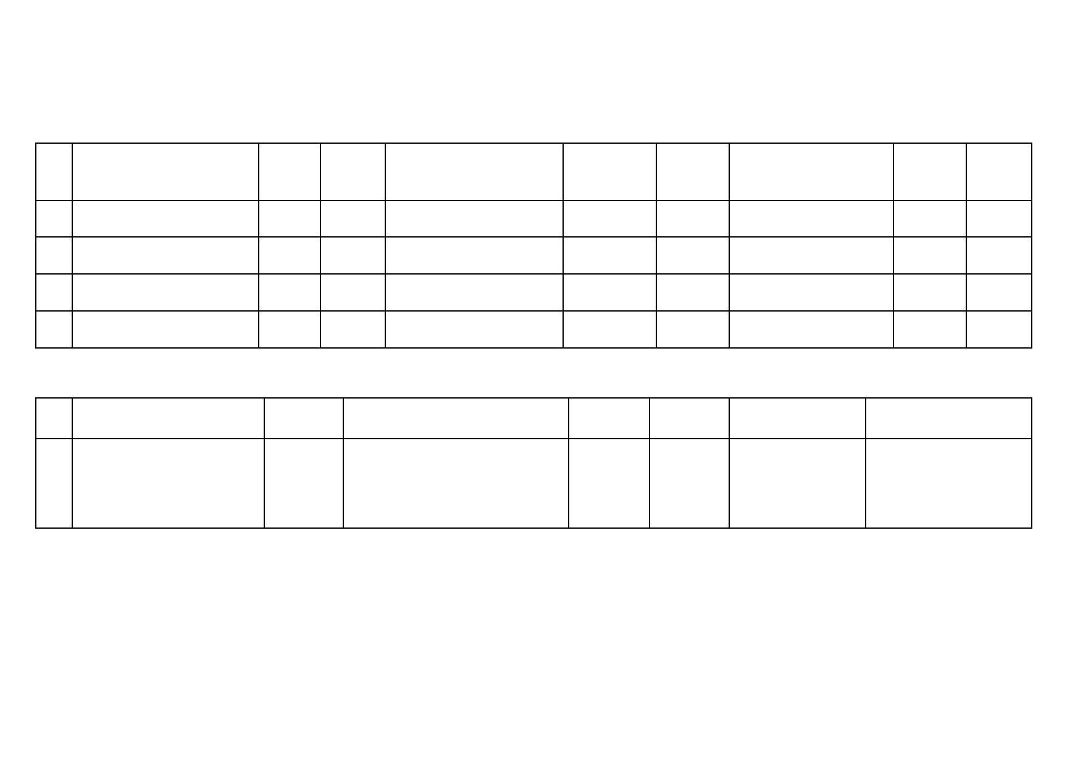-2-

11. Details of educational qualifications: Please give particulars of all examinations passed and degrees obtained commencing with the High School Leaving (10th standard / Matriculation)
Examination.
Sl. School / College / Institute Date of Date of Name of the Board Examination Distinction Subjects (Please mention field Percentage Date of
No. entry leaving / University / Institution / Degree / / Class / of specialization, honours, etc, of marks or passing
Diploma passed Division where applicable) C.P.I.
01

02

03

04

12. Details of employments: Please give particulars of your present and past employments in chronological order, starting with the present one :

Sl.
No.
Organisation / Institute
Position
held
Nature of duties / work
Date of
joining
Date of
leaving
Last Pay & Scale
of pay
Additional remarks about
experience, if any.*

I hereby declare that I have carefully read and understood the instructions and particulars supplied to me and that all the entries in this form are true to the best of my knowledge and belief.

Place:..............................
Date: ................................ Signature of the Candidate

